Risk management
Policy statement
We recognise risk is inherent in the business environment. As an employer, and as part of good corporate governance, we take steps to identify key risks; analyse the impact those risks could have; and control those risks.
By monitoring the risks to which we’re exposed, we aim to mitigate and control any impact to our core values and business objectives. By managing risk successfully we’ll protect our employees, our business assets and earning capacity, thereby contributing to the stability and development of our Group.
The group risk management process is not designed to substitute divisional ‘business as usual’ commercial and operational management. This should be managed within the division and its individual contracts. The risk management system provides a discipline to identify, review and monitor risks which could impact the performance of our Group and its divisions.
Who is involved in risk management for M Group?
The board is responsible for determining the nature and extent of the risk it’s willing to take in achieving its strategic objectives (often referred to as risk appetite). It consciously promotes a responsible approach to risk to ensure that our long-term survival and reputation are not compromised in the pursuit of growth.
The various roles and responsibilities within risk management at M Group are shown in the table below:
Who? | What role?
M Group operational board | - Responsible for risk management within our Group  - Devolves oversight of risk management to the risk board  - Reviews relevant reports  - Approves the organisation’s risk management strategy and risk management policy
Risk board reporting to M Group operational board  - Chaired by the CFO and attended by the CEO, COO, Director of internal audit & risk, Head of risk & business continuity, Head of insurance, Group commercial director, Director of ESG&I, CTO and the Group head of safety strategy improvement and reporting.  - Meets quarterly | - Proposes the organisation’s risk management strategy and risk management policy  - Reviews reports on key risks and associated action plans & assesses adequacy of action plans  - Monitors overall risk exposure and ensuring it remains within agreed appetite levels  - Provides early warnings to the board on emerging risk issues and significant exposure  - Assigns responsibility for auditing of risks  - Reviews outputs of risk assurance reviews  - Provides reports to the Audit committee
M Group audit committee  - Meets quarterly | - Reviews relevant reports  - Reviews risk management strategy and policy  - Directs the work of the Internal audit team
Divisional risk management committee (RMC)  - Chaired by the Division FD or equivalent.  - Meets quarterly | - One committee per division  - Operational responsibility for risk governance  - Oversees identification and recording of risks  - Reviews action plans for risks  - Highlights emerging risks and risks over appetite to the risk board  - Prepares risk management reports for discussion at the RMC
Divisional risk owners | - Responsible for managing risks and opportunities within their function  - Identifies, manages and monitors risks and controls via the Xactium risk management system
Group risk team reporting to CFO | - Designs and recommends the risk management policy, strategy and processes  - Implements the above once approved  - Evaluates risks on the Xactium system providing feedback to risk owners and committees  - Prepares risk management reports tailored for the relevant audience including the Risk board, Ops board and Audit committee  - Builds risk awareness across the Group by providing support and training
Internal audit team | - Conducts or procures (via external specialist assurance providers) specific audits as agreed in the internal audit plan, using the group risk management process to focus the assurance activity on the key risks of the group
Risk management policy and procedure
Further details of the M Group approach to understanding, assessing, evaluating, mitigating, monitoring and auditing risk is set out in the M Group risk management procedure.
Risk register
The output of risk management activities is recorded, by risk owners, in risk registers maintained on the Xactium risk management system. These registers record the details of the risk, the owner, the likelihood and impact ratings as well as the mitigating actions in place to manage the risk. The risks can be presented in tabular format, heat maps and dashboards to aid review and reporting.
Risk escalation
For risks that have increased to over appetite and require to be reported up to the Risk board outside of the RMC reporting period, the risk owner must inform the Head of risk & business continuity or Director of internal audit as soon as possible.
Contract risks
Risks that arise at contract or project management level, must be identified, managed, monitored and reviewed appropriately and in line with our risk management framework. Risk owners must consider the impact of the project or contract level risk on the overall division’s risk profile. If the impact is significant, the risk must be reported up to the Division risk chair immediately. The Division risk chair must have oversight of these risks on a regular basis.

Risk assurance
M Group has an integrated assurance model. There are several different assurance providers in our business, all of whom contribute to effective risk management. The diagram below explains this:
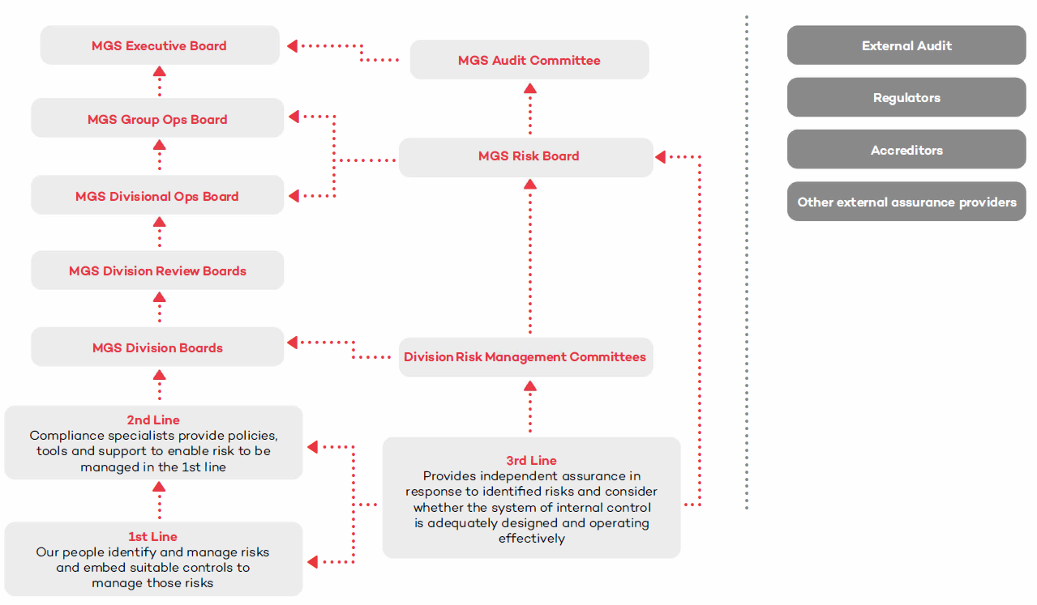
Internal audit plan
The Audit committee directs the work of the internal audit team whose function is to provide independent and objective insight, advice and assurance across all businesses in the Group. The internal audit plan is risk based, aiming to improve the effectiveness of governance, risk management, and control processes. The internal audit plan and the outputs of any internal audit work are reviewed by the risk board on a quarterly basis and the key outputs are reported to the M Group operational board and the Group audit committee.
Outputs and reporting
The risk management process helps management make strategic, operational and investment decisions with risks in mind. The risk team will regularly review and report on the content of the risk registers and provide management with a series of reports to outline key risks and emerging issues within the Group. Divisions also produce risk reports for discussion at the RMCs. Outputs and actions required from assurance work will also be provided. The reporting includes:
Report | Content | Frequency
Division level risk summary | - Top risks and controls being managed (including over appetite)  - Adequacy of controls being undertaken to manage the top risks and/or actions for proposed improvements to controls  - Emerging risks  - Details of risk assurance work undertaken, including internal audit reports and summary of whistleblowing investigations  - Mandatory training compliance  - Numbers of gifts, hospitality and conflicts of interest declarations  - Material risks  - Insurance claims | Quarterly
Group level risk summary | - KPI risk management dashboard  - Group level risk heat map  - Risks over appetite and action plans  - Emerging risks and issues  - Material risks and controls  - Mandatory training compliance  - Numbers of gifts, hospitality and conflicts of interest declarations  - Insurance update  - Business continuity planning status  - Outputs from internal audit work  - Summary of whistleblowing investigations  - Output from other assurance work | Quarterly
Ops board report | - KPI risk management dashboard  - Group level risk heat map  - Risks over appetite and action plans  - Mandatory training compliance  - Numbers of gifts, hospitality and conflicts of interest declarations  - Summary of internal audit work and whistleblowing investigations  - Summary of other assurance work reported to the risk board  - Summary of actions required for effective business continuity planning | Quarterly
M Group audit committee report | - Summary of risk management activity  - Summary of assurance activity  - Summary of whistleblowing investigations  - Progress against the internal audit plan | Quarterly

